Computer Science Project

**Student Link up**

**Members: Jayesh Somani, Kunal Kundaliya, Yatharth Bachhan**

Table of Contents:

|  |  |  |
| --- | --- | --- |
| S.no | Tittle | Page No: |
| 1. | Getting Started:  a.Prerequisites, INSTALLATION |  |
| 2. | Project Structure |  |
| 3. | Usage:  a.Running the App |  |
| 4. | Source Code |  |
| 5. | Real World uses:  A-team |  |
| 6. | Bibliography |  |

Student Link up Project:

## **Overview:**

Student Link Up is an app that brings everything students need into one place. Check your grades, get feedback from teachers, stay updated on events and exams, view results, and even see what’s on the menu—all in one app.

## **Getting Started**

### Prerequisites:

**Before you begin ensure that following items are already installed:**

**- Python https://**[**www.python.org**](http://www.python.org/) **(version3.x recommended)**

­

### Installation

1. Install the required packages:

|  |
| --- |
| pip install fpdf ===1.7.2 |
| pip install mysql-connector-python ===9.0.0 |
| pip install packaging===24.1 |
| pip install pillow===11.0.0 |
| pip install tk=== 0.1.0 |
| pip install tkcalendar === 1.6.1 |
| pip install pyinstaller === 6.11.0 |
| pip install PyMySQL === 1.1.1 |

1. Navigate to the project directory:

Cd "C:\Users\Gateway\Desktop\computer tkinter"

3. Modules used:

|  |  |
| --- | --- |
| **Module Name** | **Module Name** |
| tkinter | Used for creating GUI applications (widgets, layout management, event handling). |
| |  |  | | --- | --- | | OptionMenu |  | | Provides a drop-down menu for options in the GUI. |
| scrolledtext | |  | | --- | | Provides a widget for displaying and editing multi-line text with scrollbars. | |
| |  |  | | --- | --- | | filedialog |  | | Used for file selection dialogs (open/save). |
| |  |  | | --- | --- | | font |  | | Used for specifying and managing fonts in Tkinter widgets. |
| |  |  | | --- | --- | | StringVar |  | | A special variable type in Tkinter that holds string data, linked with widgets. |
| |  |  | | --- | --- | | ttk | . | | Themed widget set in Tkinter for modern-styled widgets. |
| |  |  | | --- | --- | | PhotoImage |  | | Handles image formats like .gif and .png for use in Tkinter widgets. |
| |  |  | | --- | --- | | PIL.Image |  | | Used to open, manipulate, and save different image file formats (Pillow library). |
|  |  |
| |  |  | | --- | --- | | pymysql |  | | Used to interact with MySQL databases (for querying and executing commands). |
| |  |  | | --- | --- | | datetime |  | | Provides classes for manipulating dates and times. |
| |  |  | | --- | --- | | timedelta |  | | Used to represent the difference between two datetime objects. |
| |  |  | | --- | --- | | tkcalendar |  | | Provides a calendar widget for selecting dates. |
| |  |  | | --- | --- | | webbrowser |  | | Allows opening URLs in the default web browser. |

## **Project Structure**:

### **|--Login centre.py**

**Login centre.py**: **It** is an all-in-one platform for students and parents, offering secure login, school fee payment options, and access to important academic information such as report cards and assignments. It also provides reading materials in PDF format, allows feedback submission, and includes settings for account management. Additionally, the platform features an "About Us" section and offers admission forms for new students.

## **Usage**

### Running the app

1. Open a terminal or command prompt.
2. Navigate to the project directory:

Installer – {OneFile} login center.py

Cd "C:\Users\Gateway\Desktop\computer tkinter"

1. Run the program:
2. The executable file will be created in the `dist. /` directory.
3. Locate and run the generated executable (`login center.exe` on Windows).

## Source Code



**https://github.com/Kunal022-del/DPS-BPKIHS-SCHOOL/blob/d525e628efab5df11844cd89f77fdd1b2babfc2c/login_01.py**

### Output

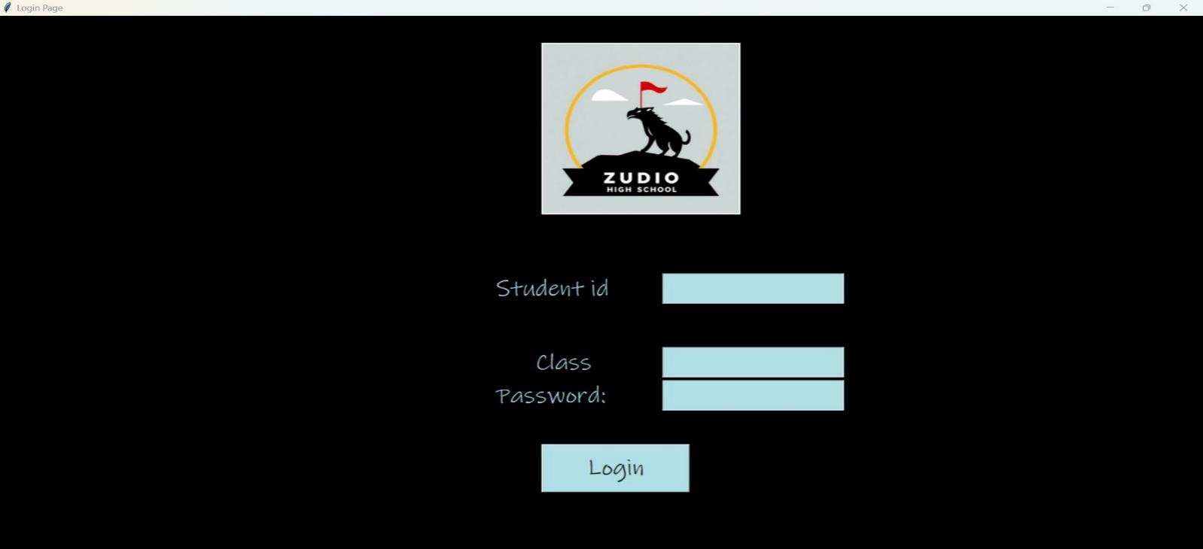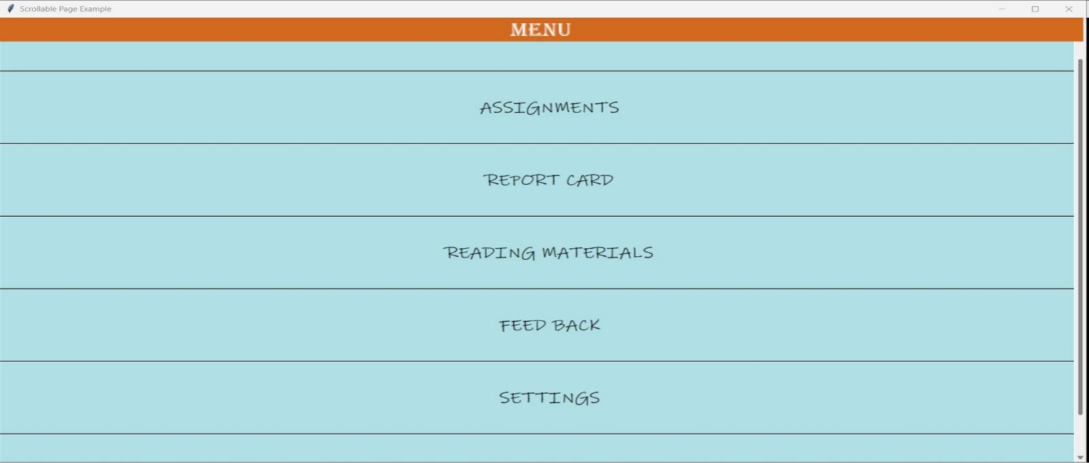

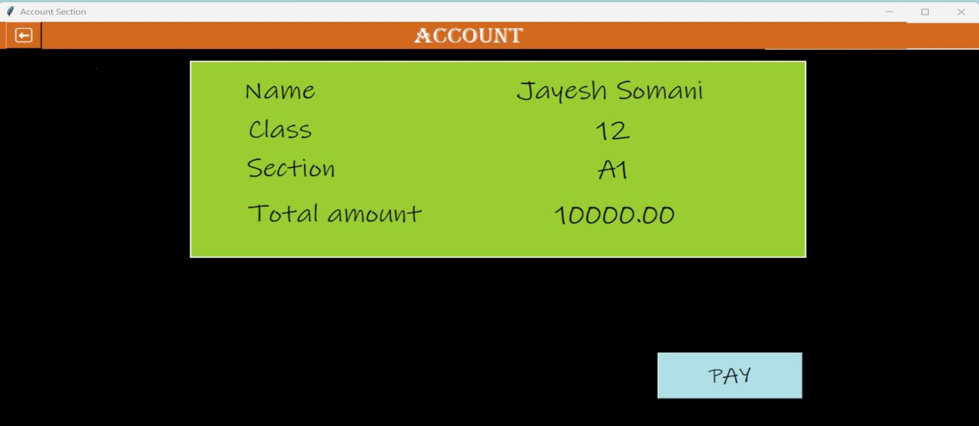

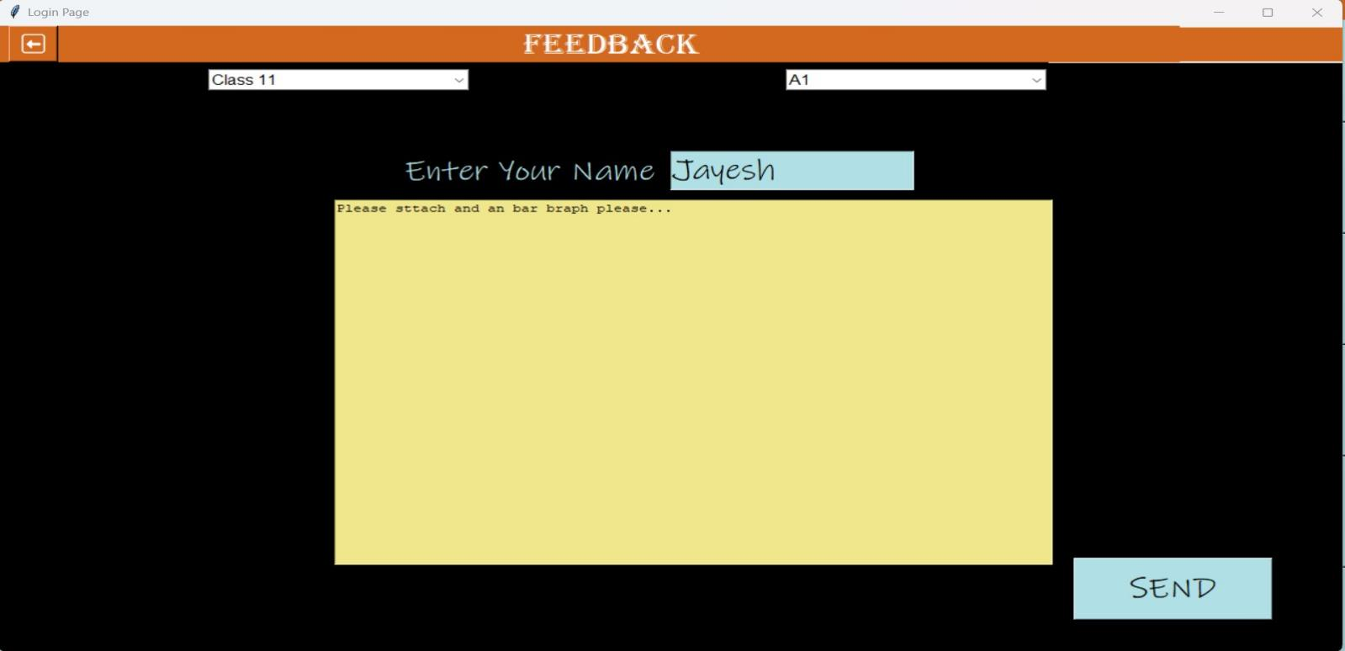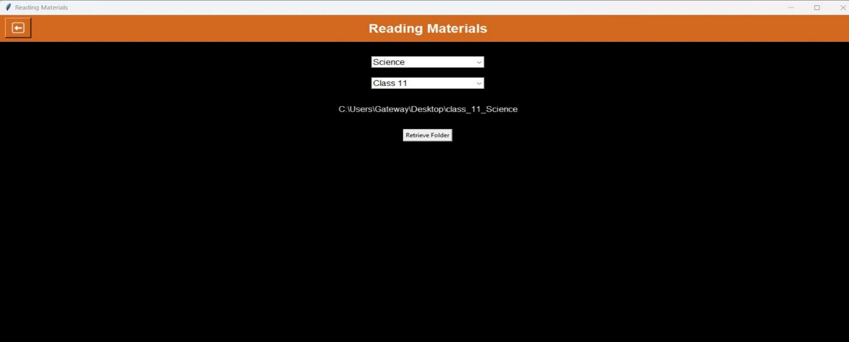

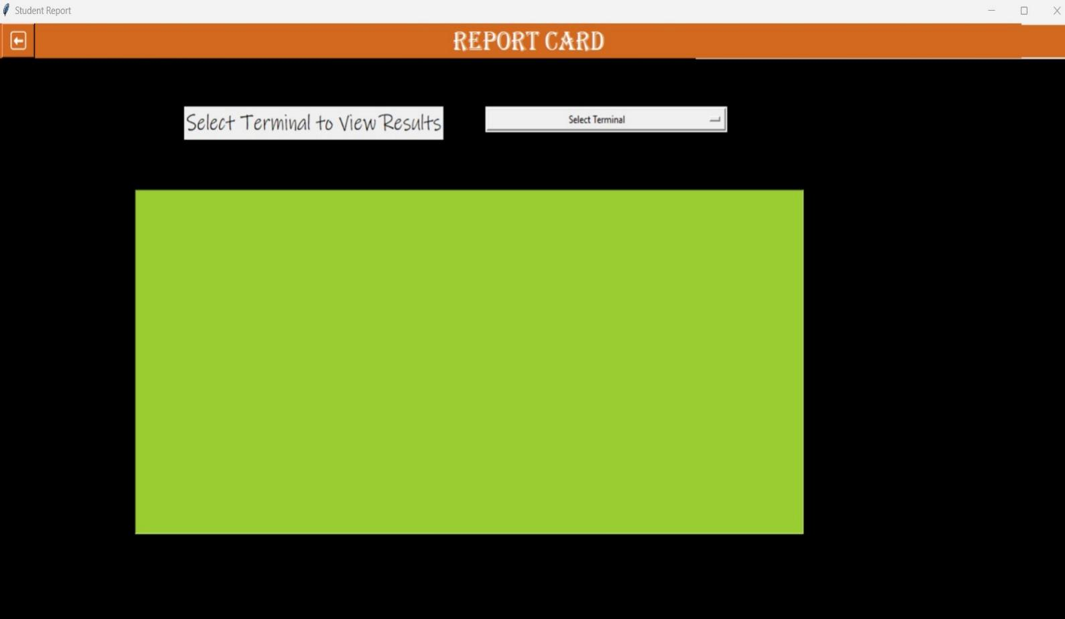

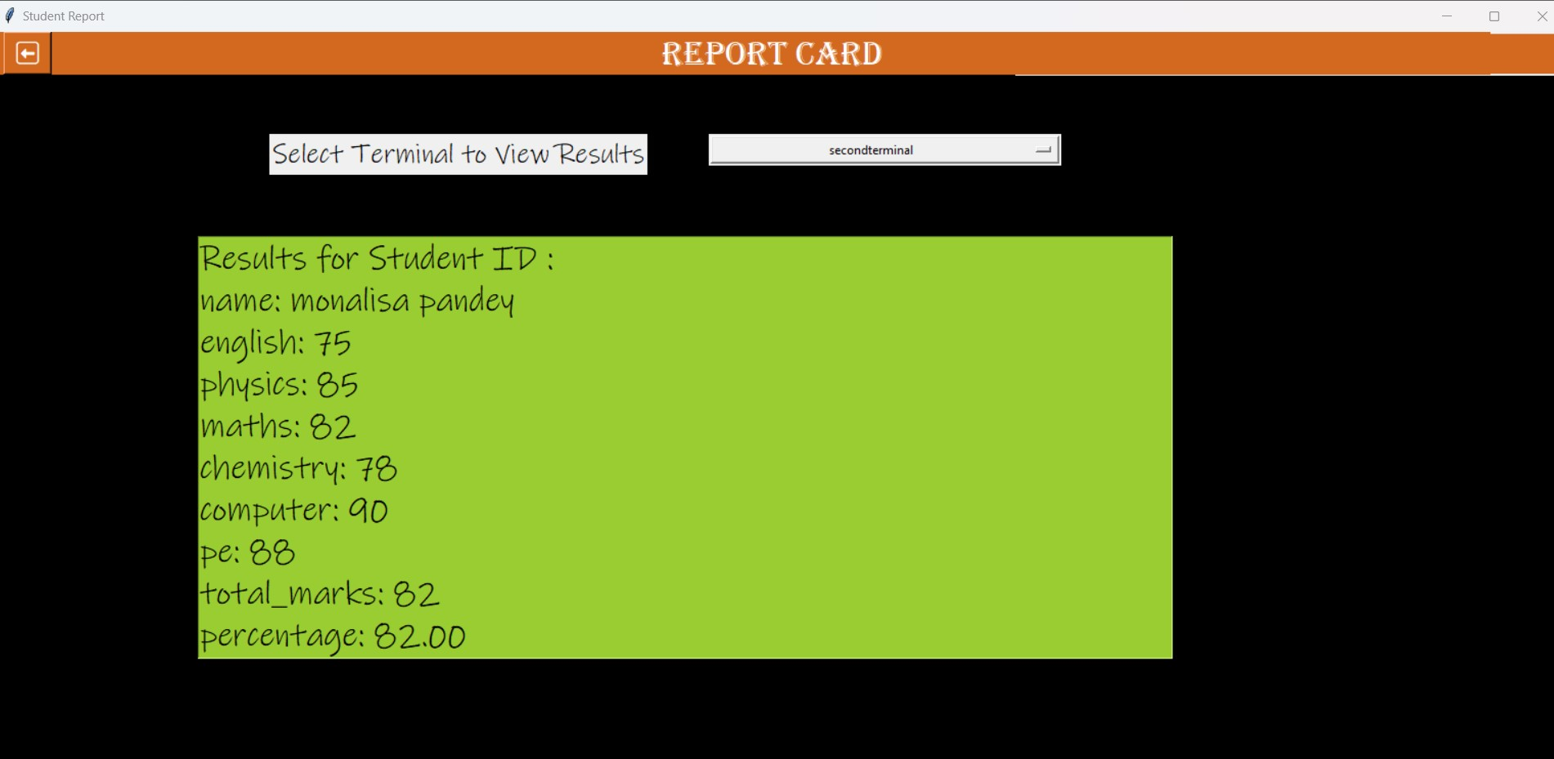

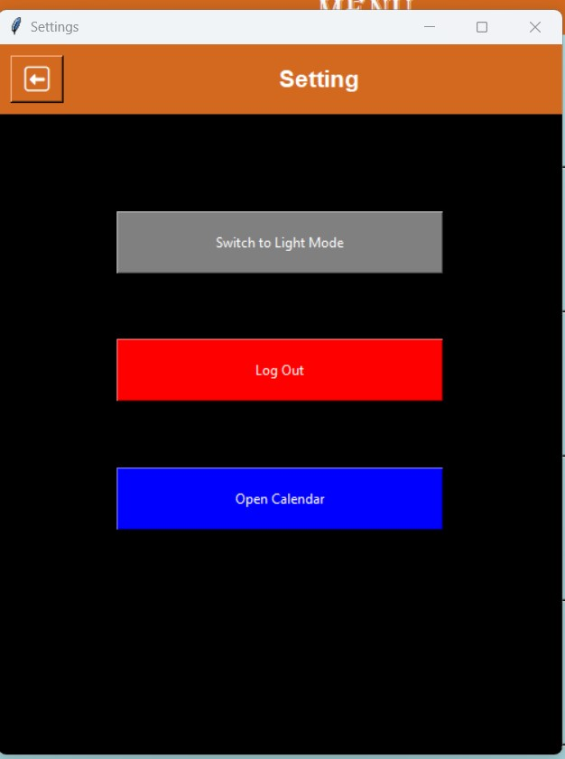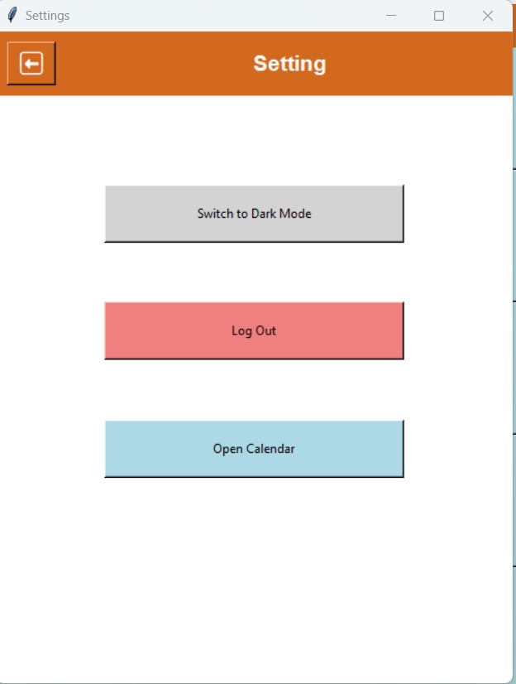

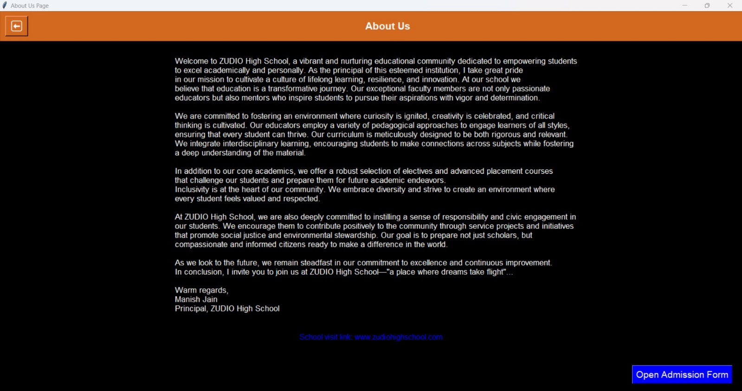

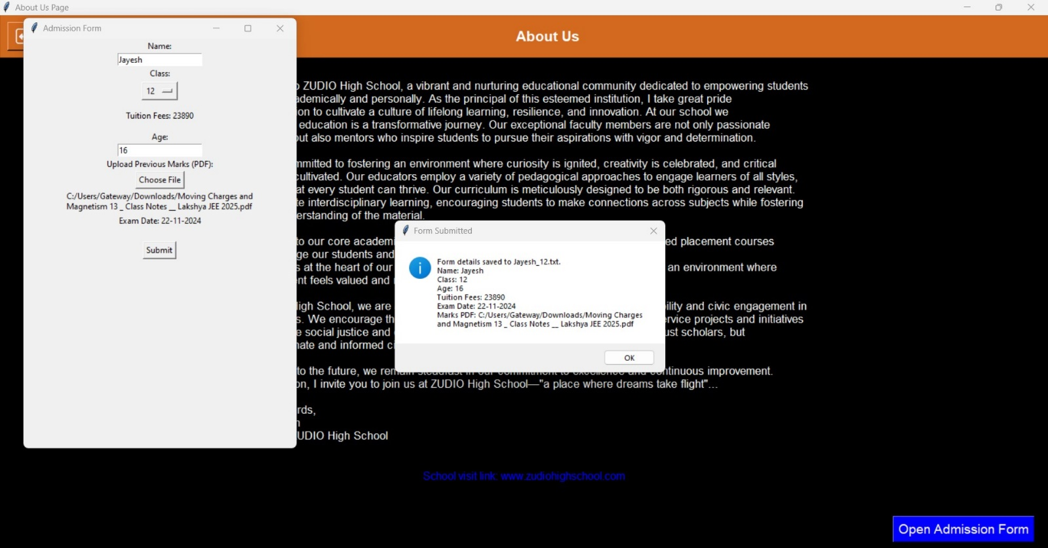

## **Real-World Uses:**

The **Student Link Up** app offers a comprehensive platform for students to manage their academic journey efficiently.

In the **Account** section, you can update personal information, pay fees seamlessly through mobile payment options, and manage contact details.

The **Assignments** area allows you to submit ongoing assignments, track progress, and set reminders for upcoming deadlines to stay organized.

The **About Us** section provides valuable insights into the principal and the school's mission, helping you understand the educational environment.

In the **Feedback** section, you can share your thoughts and responses.

The **Reading Materials** section grants easy access to essential course readings and textbooks.

The **Settings** area lets you toggle between light and dark modes, log out securely, and modify your calendar preferences for better time management.

### Team:

1. **Jayesh Somani**: As the team leader, Jayesh Somani will oversee the project’s progress, ensuring alignment with overall goals and objectives. He will guide team members in developing code and provide direction to ensure best practices are followed throughout the project.

2. **Yatharth Bachhhan**: As a Software Developer, Yatharth Bachhhan will focus on coding, implementing new features, and ensuring the overall functionality of the project. He will work closely with the team to optimize the codebase and ensure seamless integration of all components.

3. **Kunal Kundaliya**: Kunal, as the Quality Assurance (QA) Analyst, will be responsible for testing the app, identifying bugs, and ensuring its reliability. His efforts will be vital in maintaining the overall quality and functionality of the project.

## **Bibliography:**

* + [**www.python.org**](http://www.python.org/)
  + **https://www.w3schools.com/python/python_mysql_create_db.asp**